Information Function
NOTE: This function returns TRUE or FALSE.
INPUT DATA : 1) Information -table
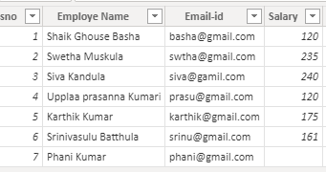
2) filter -table

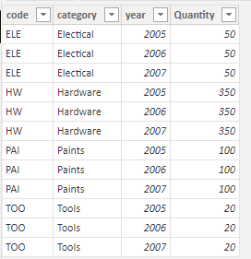
1)CONTAINS: By using this function, we can find the single value in the given column.
Syntax: CONTAINS(<table>, <columnName>, <value>[, <columnName>, <value>]…)
NOTE: If finding value is exist in that given column, then it returns true for each in these column values, otherwise it returns false.
In this function, we can find single value only.
If we want find multiple values then will go to “CONTAINSROW” function.
Dax Function:
1) contains = CONTAINS(Information,
Information[Salary],240
)
2) Conatins1 = CONTAINS(Information,
Information[Salary],121
)

Output: 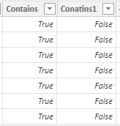

2)CONTAINSROW: By using this function we can find the multiple values in the given table.
Syntax: CONTAINSROW(<Table>, <Value> [, <Value> [, …] ] )
NOTE: If finding values are exists in at least one row, then it returns true for each in those columns, otherwise it returns false.
In this function we can use multiple values also.
Difference between “contains” and “containsRow” is in that contains find single value only, but in this containsRow find multiple values also.
Dax Function: containsrow = CONTAINSROW({120,235},Information[Salary])
Output:
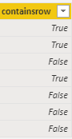

3) CONTAINSSTRING : By using this function we can find the text string content.
Syntax: CONTAINSSTRING(<within_text>, <find_text>)
NOTE: It just like as “Search” function.
It is not case-sensitive.
In this function, find text is in within text not exactly place on order.
In this function, we can use wild characters for finding the text.
Dax Function: 1) Containsstring = CONTAINSSTRING(Information[Employe Name],"basha")
2) Containsstring1 = CONTAINSSTRING(Information[Employe Name],"Basha")
3) containsstring2 = CONTAINSSTRING(Information[Employe Name],"*k")
4) containsstring3 = CONTAINSSTRING(Information[Employe Name],"k*r")
Output: 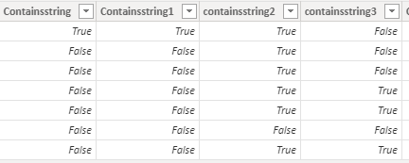

4)CONTAINSSTRINGEXACT : By using this function we can find the text string content.
Syntax: CONTAINSSTRINGEXACT(<within_text>, <find_text>)
NOTE: It just like as “Find” function.
It is case-sensitive.
In this function, find text is in within text exactly place on order.
In this function, we can’t use wild characters for finding the text.
Difference between “containsstring” and “containsstringexact” is,
“containsstirng”
Is not case –sensitive,
Like as “serach” function,
Not required for exact find text position
And also use in wild characters for finding text

But in
“containsstringexact”
Is case-sensitive,
Like as “Find “function,
Must required for exact text position
And not used for wild characters for finding the text.

Dax Function : 1) Containsstringexact = CONTAINSSTRINGEXACT(Information[Employe Name],"basha")
2) Containsstringexact1 = CONTAINSSTRINGEXACT(Information[Employe Name],"Basha")
3) containsstringexact2 = CONTAINSSTRINGEXACT(Information[Employe Name],"*k")
Output: 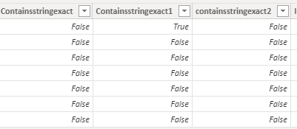

5) ISBLANK: By using this function, we can check whether a value is blank or not.
If it’s blank then it returns true, otherwise it returns false.
Syntax: ISBLANK (<value>)
Dax Function: Isblank = ISBLANK(Information[Salary])
Output:
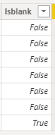
6) ISEMPTY: By using this function, we can check whether a table is empty or not.
If its table is empty (has no rows) then it returns true, otherwise it returns false.
Syntax: ISEMPTY(<table_expression>)
Dax Function: Isempty = ISEMPTY(Information)
Output:
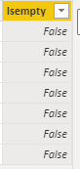
7) USERNAME: By using this function we can find the domain name.
Syntax: USERNAME ()
NOTE: It returns domain name and username from the credentials given to the system at connection time.
This function has no parameters.
It’s give Row-level security
Dax Function: If (CONTAINS (USERTABLE,USERTABLE[LOGIN], USERNAME(),”Allowed”,BLANK ())
Example:
8) USERPRINCIPALNAME: By using this function we can find the Email-id
Syntax: USERPRINCIPALNAME ()
NOTE: It returns EMAILID from the credentials given to the system at connection time.
This function has no parameters.
It’s give Row-level security.
Dax Function: If (CONTAINS (USERTABLE,USERTABLE[LOGIN], USERPRINCIPALNAME(),”Allowed”, BLANK ())

9)HASONEFILTER : By using this we can select any one value in that particular column then it returns True, otherwise it returns false.
Syntax: HASONEFILTER(<columnName>)
NOTE: This function can apply in measure only.
In this we can use only single column performance.
HASONEFILTER is work by a “single Direct filter”.
Dax Function: has1filter = HASONEFILTER('filter'[category])
10)HASONEVALUE : By using this we can select any one value in that particular column then it returns True, otherwise it returns false.
Syntax: HASONEVALUE(<columnName>)
NOTE: This function can apply in measure only.
In this we can use only single column performance.
HASONEVALUE is work by a “Single Direct filter”, single cross-filter .
Dax Function: Has1value = HASONEVALUE('filter'[category])
11)ISFILTERED: By using this we can select any one value in that particular column then it returns True, otherwise it returns false.
Syntax: ISFILTERED(<TableNameOrColumnName>)
NOTE: This function can apply in measure only.
In this we can use only single column or single table performance.
ISFILTERED is work by a “Single Direct filter”, multiple filter.
Dax Function: Isfiltered = ISFILTERED('filter'[category])
Outputs: If no one value select then all filter function returns “FALSE” like as,
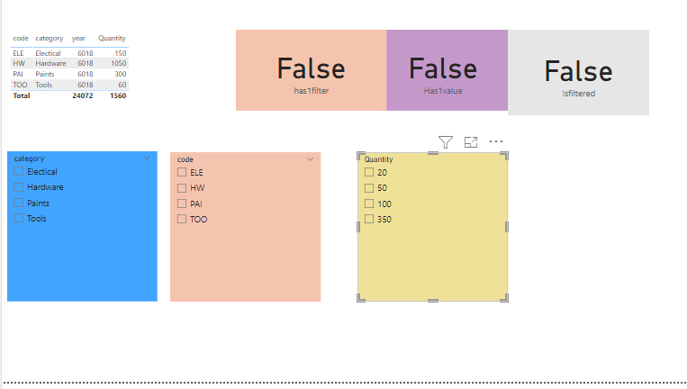

Note: Now iam filtering “category” ,I mean direct filter is “Category”.
- Now I select any one value in category, then these 3 filters are return “TRUE”, why because these 3(Has1filter,Has1value and Isfiltered) are used by “singleDirect filter.

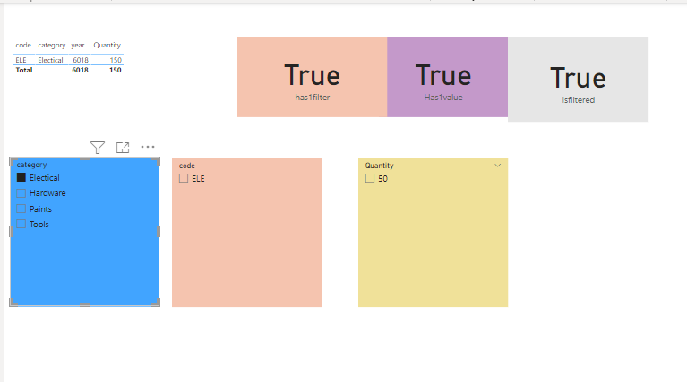
2)Now iam selecting multiple values in category filter, then only “ISFILTERED” return “True”, reaming filters are “False” why because “ISFILTERED” used by multifilter”.
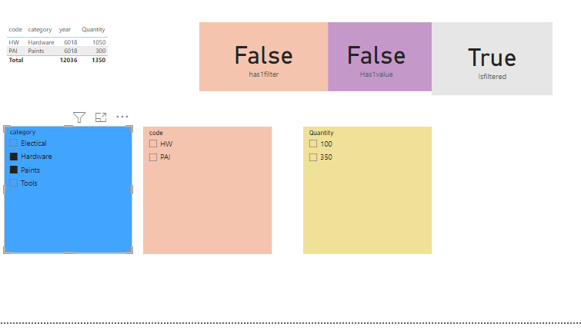
3)Now iam selecting indirect filter then only “HASONEVALUE” filter will be True”, reaming filter are return “false”,why because “HasoneValue” filter used by “cross filter”.
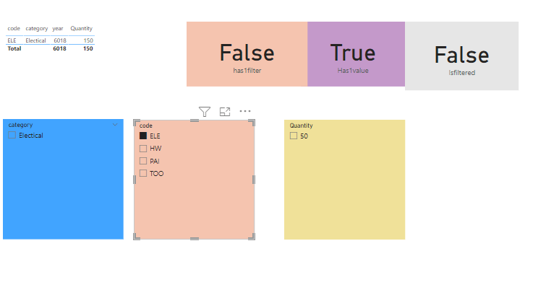
12) ISEVEN: By using this function, we can check whether the value is even or not.
If it is even then it returns True, otherwise it returns False.
Syntax: ISEVEN(number)
Dax Function : Iseven = ISEVEN(Information[Salary])
Output :
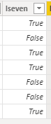
13) ISODD: By using this function, we can check whether the value is odd or not.
If it is odd then it returns True, otherwise it returns False.
Syntax: ISODD(number)
Dax Function: Isodd = ISODD(Information[Salary])
Output:
